Task 1
Data structures:
Data structure define how data is organized , stored and manipulated within a program. It also helps us to access the date timely and efficient. It also helps us to develop efficient and effective algorithms.
Task2:
Types of data structure:
Arrays
Strings
Collection(List, Sort, Map, Set, Queue)
Stacks
LinkedList
Trees
Graphs
Hash Tables
Task3:
What all operations can we do in Data structures?
We can do fundamental actions like insertion, deletion, searching, and sorting, as well as more specialized operations depending on the specific data structure. Examples include traversal , merging data from different structures, and updating existing data elements.
Task4:
- Static Array: In this type of array, memory is allocated at compile time having a fixed size of it. We cannot alter or update the size of this array.
- Dynamic Array: In this type of array, memory is allocated at run time but not having a fixed size. Suppose, a user wants to declare any random size of an array, then we will not use a static array, instead of that a dynamic array is used in hand. It is used to specify the size of it during the run time of any program.

Feature | Static Array | Dynamic Array
Size | Fixed size, declared at compile time | Resizable, can grow or shrink during runtime
Memory Allocation | Typically allocated on the stack | Typically allocated on the heap
Performance (Access) | Fast (O(1) for random access) | Fast (O(1) for random access), but potentially slower during resizing due to memory reallocation
Flexibility | Less flexible, size must be known in advance | More flexible, can adapt to changing data needs
Limitations | Limited by declared size, potential overflow if not enough space | Resizing can be slower if reallocation is needed, potential memory overhead due to reallocation
Examples | int arr[10]; (C/C++) | ArrayList (Java), std::vector (C++)

Task 5:
What is the binary value of a?
01100001
Task 6:
Types of Computer memory with examples.. Explain ..
Computer memory can be broadly categorized into primary (or main) memory and secondary memory. Primary memory, like RAM and cache, provides fast access to data actively being used by the CPU. Secondary memory, such as hard drives and SSDs, offers larger storage capacity for long-term data retention
Task 7:

Reverse an array. write a code.

11.50 to 11.54

Hint : take a list of nos and display in reverse order..
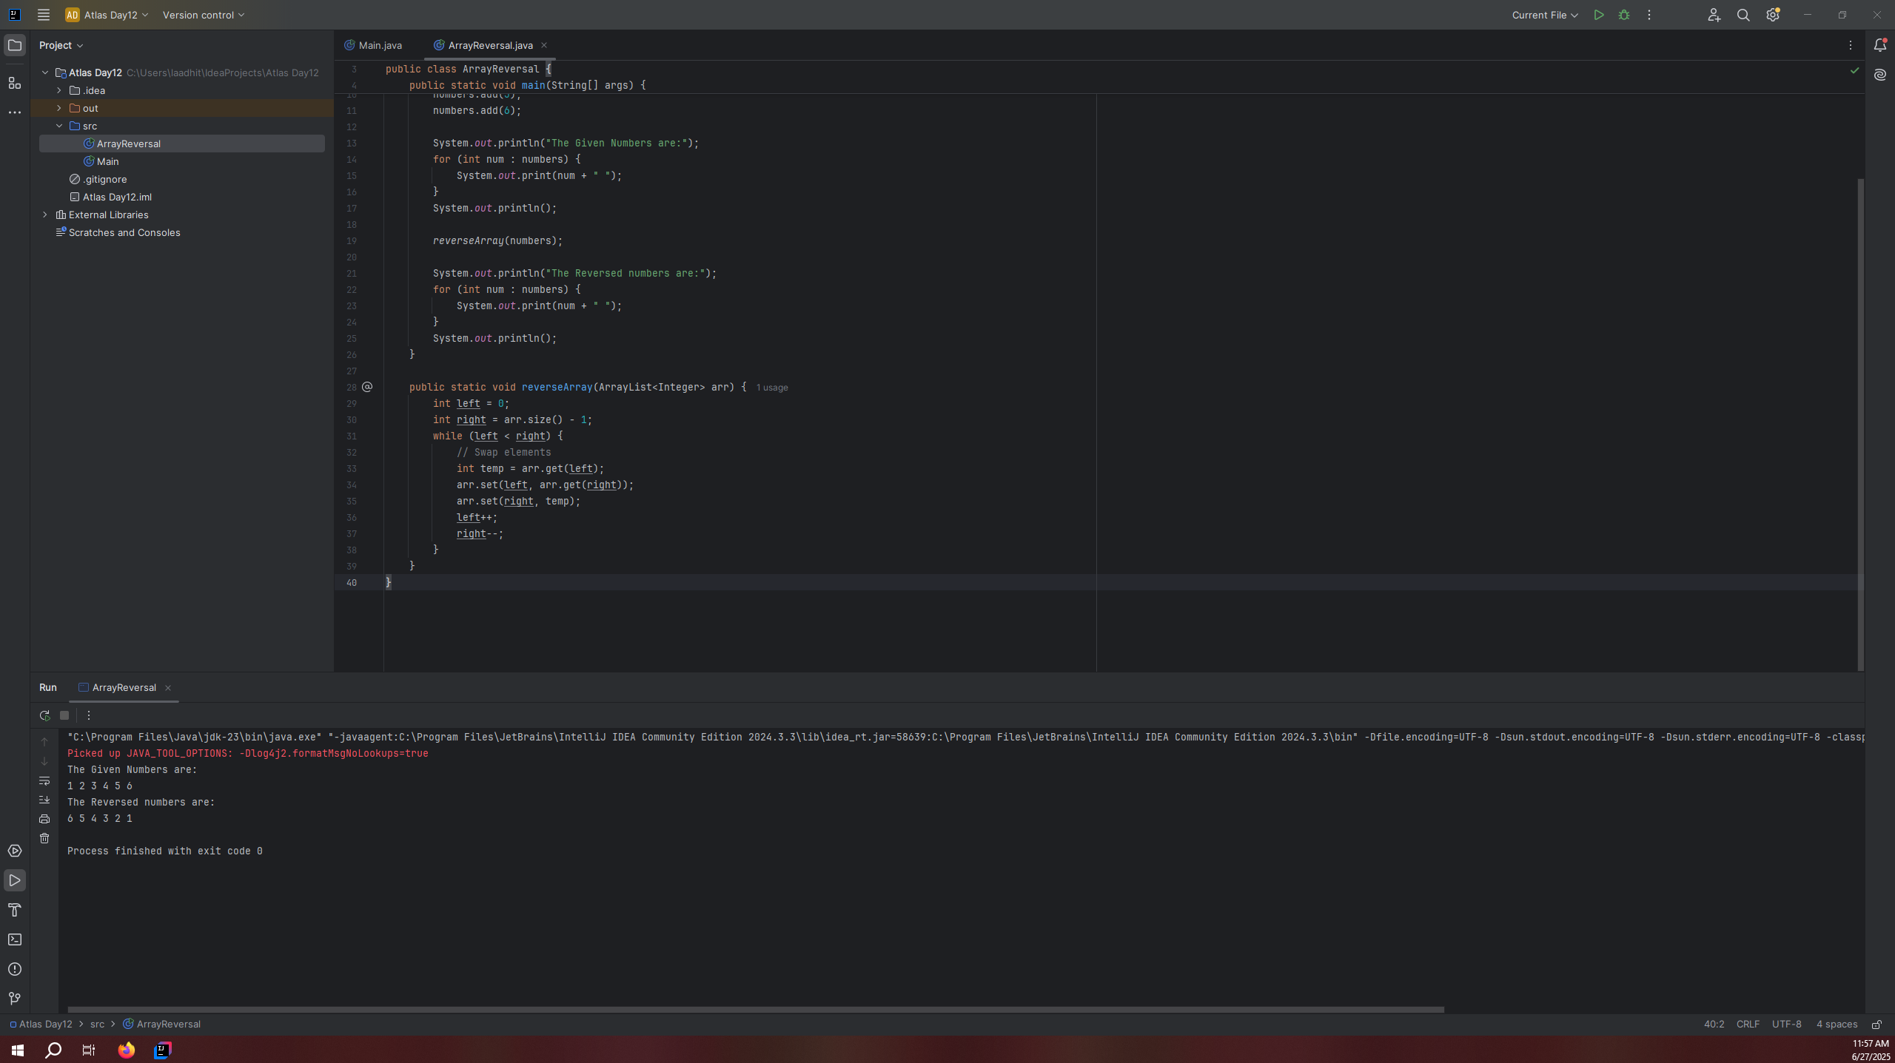
import java.util.ArrayList;
public class ArrayReversal {
public static void main(String[] args) {
ArrayList<Integer> numbers = new ArrayList<>();
numbers.add(1);
numbers.add(2);
numbers.add(3);
numbers.add(4);
numbers.add(5);
numbers.add(6);
System.out.println("The Given Numbers are:");
for (int num : numbers) {
System.out.print(num + " ");
}
System.out.println();
reverseArray(numbers);
System.out.println("The Reversed numbers are:");
for (int num : numbers) {
System.out.print(num + " ");
}
System.out.println();
}
public static void reverseArray(ArrayList<Integer> arr) {
int left = 0;
int right = arr.size() - 1;
while (left < right) {
// Swap elements
int temp = arr.get(left);
arr.set(left, arr.get(right));
arr.set(right, temp);
left++;
right--;
}
}
}
Task 8:

Reverse a string .. write a code.
import java.sql.Statement;
public class StringReversal {
public static void main(String[] args) {
String original = "Hello, World";
System.out.println("Original String: " + original);
System.out.println("Reverse String: " + reverseUsingStringBuilder(original));
System.out.println("Reverse String: " + reverseUsingCharArray(original));
}
public static String reverseUsingStringBuilder(String str) {
return new StringBuilder(str).reverse().toString();
}
public static String reverseUsingCharArray(String str) {
char[] charArray = str.toCharArray();
int left = 0;
int right = charArray.length -1;
while (left<right) {
char temp = charArray[left];
charArray[left] = charArray[right];
charArray[right] = temp;
left++;
right--;
}
return new String(charArray);
}
}
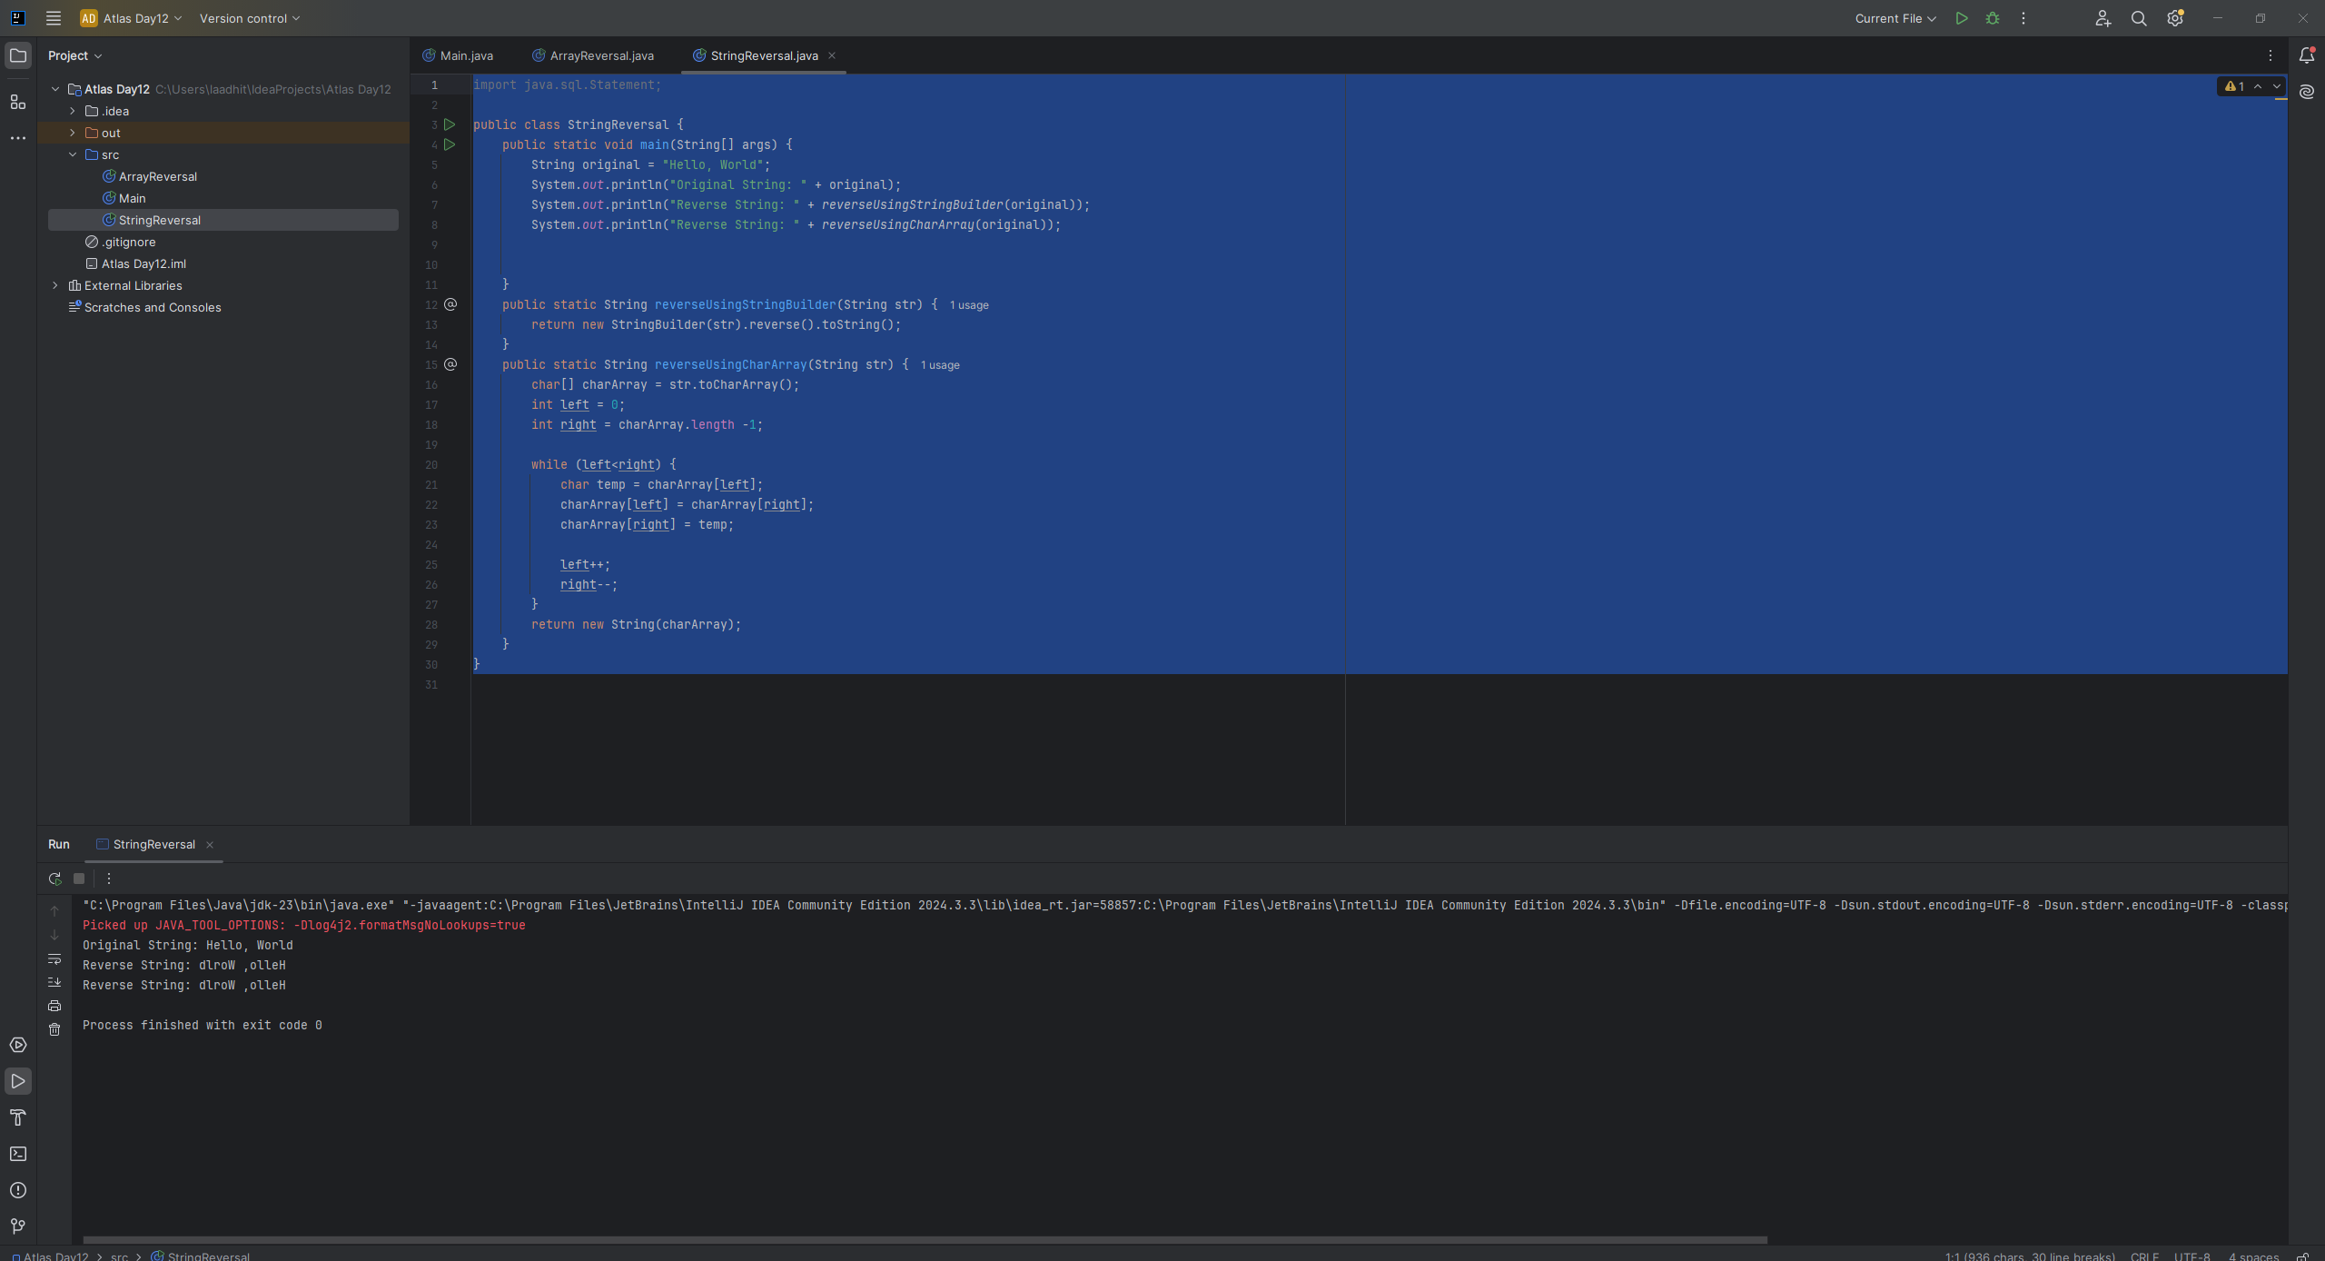

Task 10
import java.util.Arrays;
public class Example {
public static void main(String[] args) {
int[] arr1 = {11, 34, 66, 75};
int n1 = arr1.length;
int[] arr2 = {1, 5, 19, 50, 89, 100};
int n2 = arr2.length;
int[] merge = new int[n1 + n2];
int i = 0, j = 0, k = 0, x;
System.out.print("Array 1: ");
for (x = 0; x < n1; x++)
System.out.print(arr1[x] + " ");
System.out.print("\nArray 2: ");
for (x = 0; x < n2; x++)
System.out.print(arr2[x] + " ");
while (i < n1 && j < n2) {
if (arr1[i] < arr2[j])
merge[k++] = arr1[i++];
else
merge[k++] = arr2[j++];
}
System.out.println();
System.out.println("Merged Array:" + Arrays.toString(merge));
while (i < n1)
merge[k++] = arr1[i++];
while (j < n2)
merge[k++] = arr2[j++];
System.out.print("\nArray after merging: ");
for (x = 0; x < n1 + n2; x++)
System.out.print(merge[x] + " ");
}
}
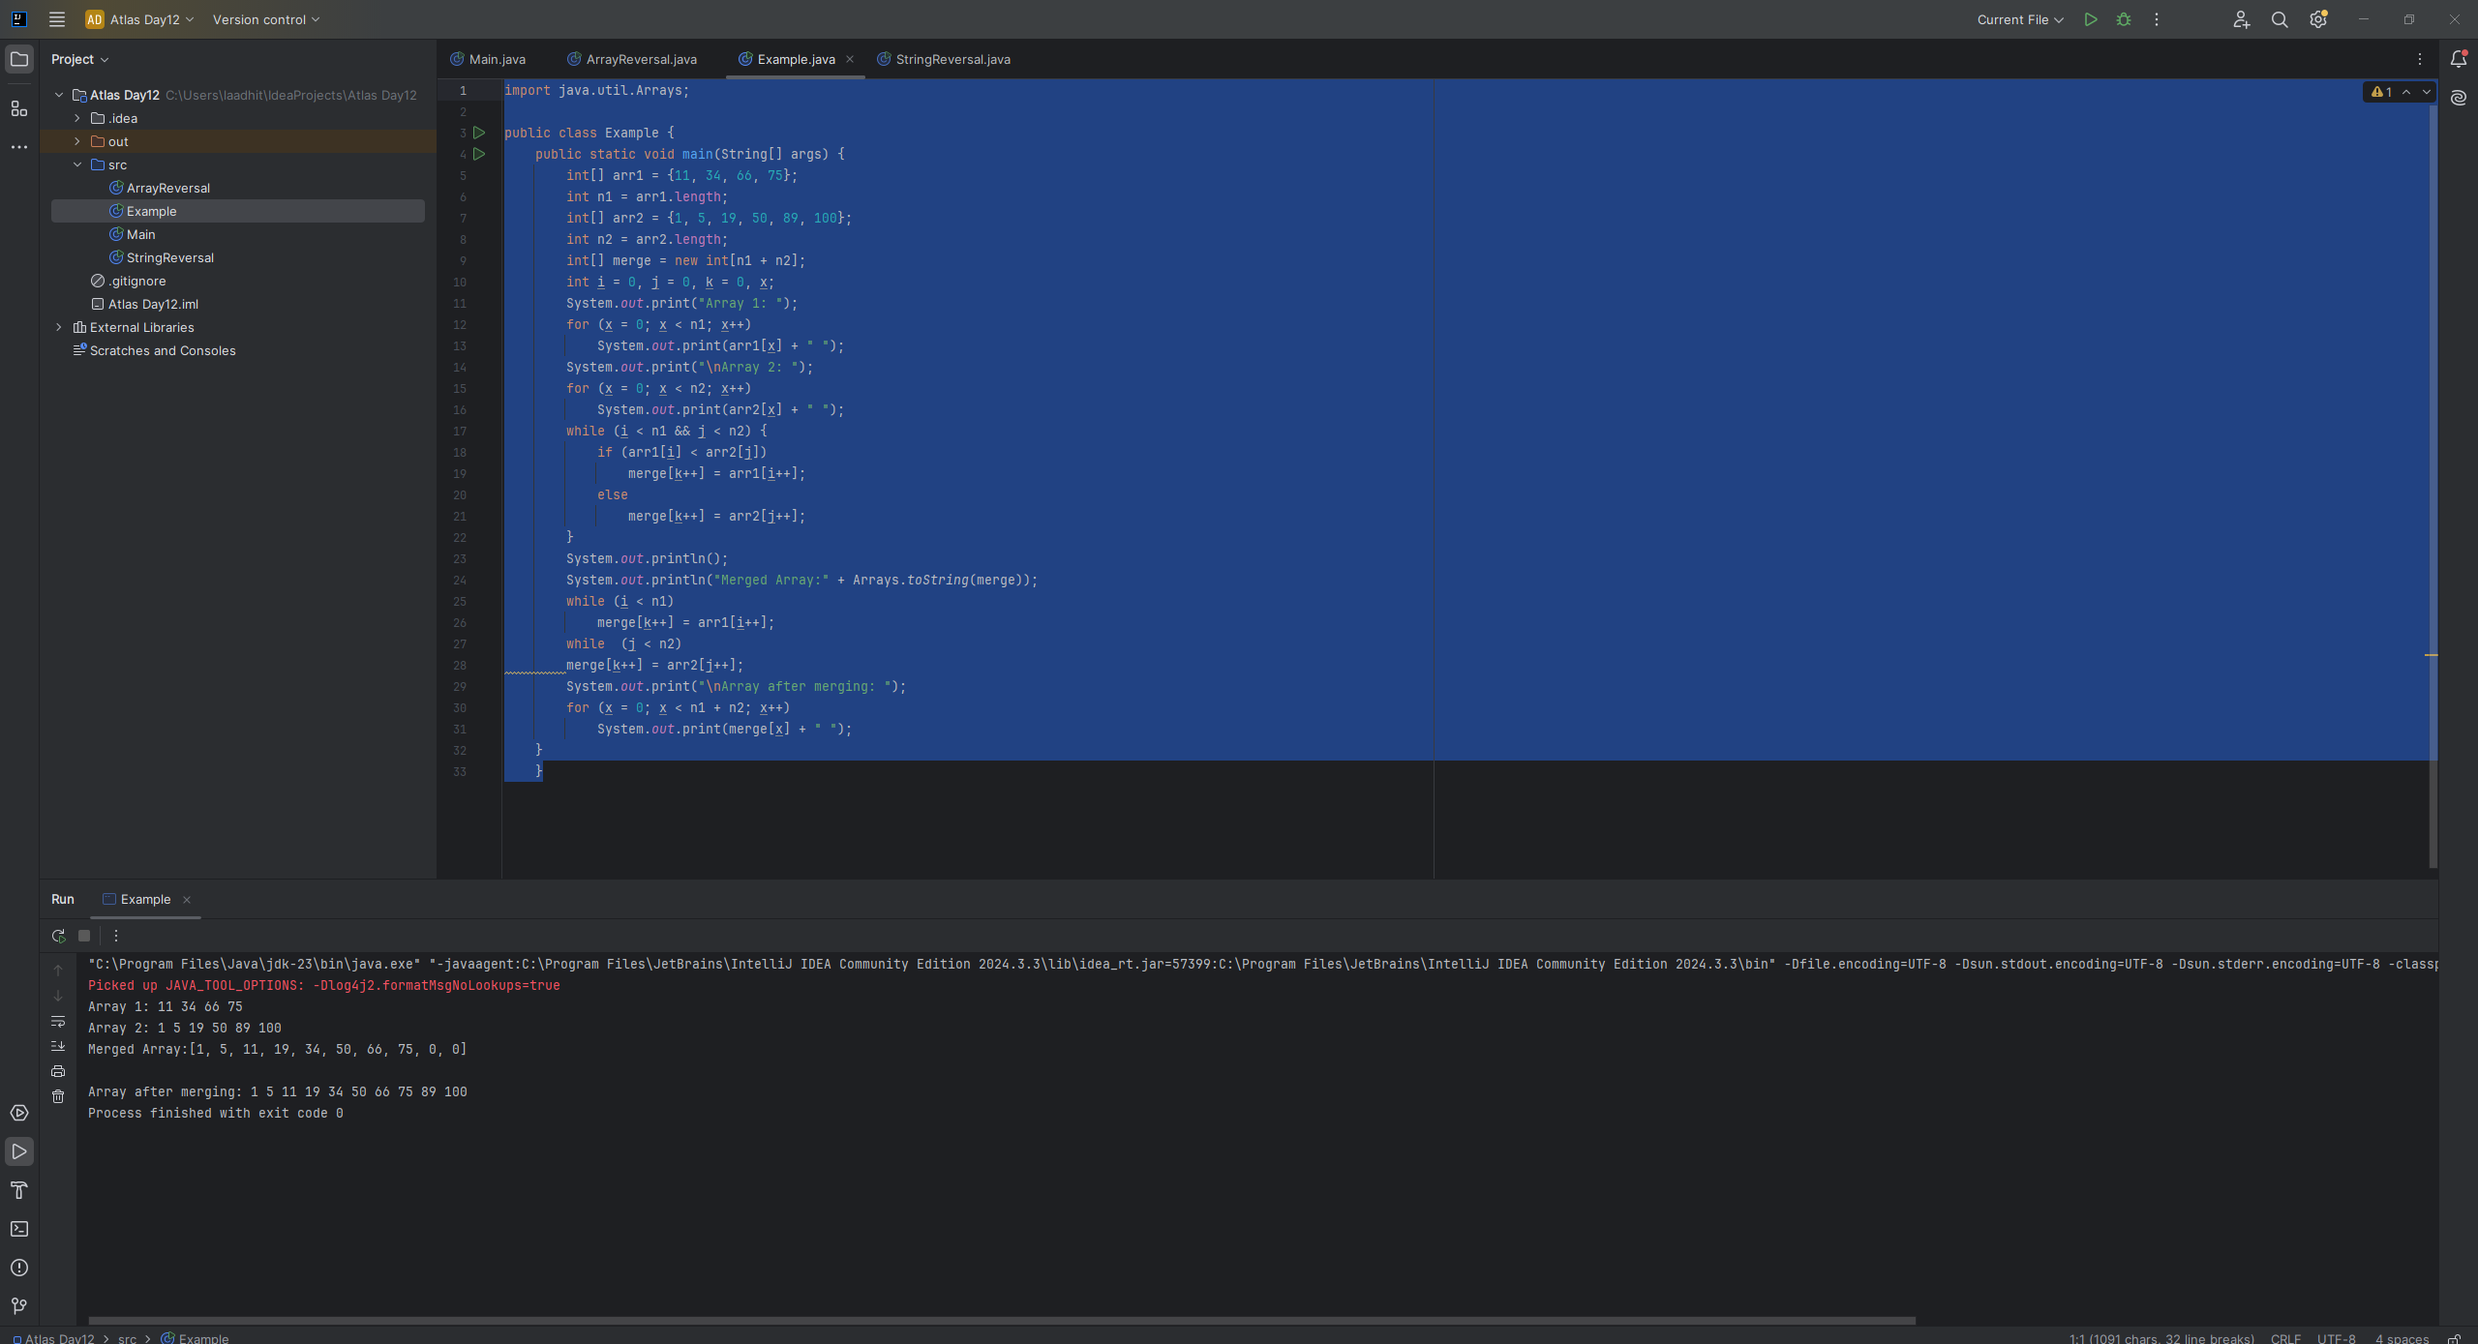
Task11:
What do you understand by Hash table?
A hash table is a type of data structure in which information is stored in an easy-to-retrieve and efficient manner. In the key-value method, keys are assigned random indexes where their values are stored in an array. The index is the information of where exactly in the array the value is stored.
Task12:
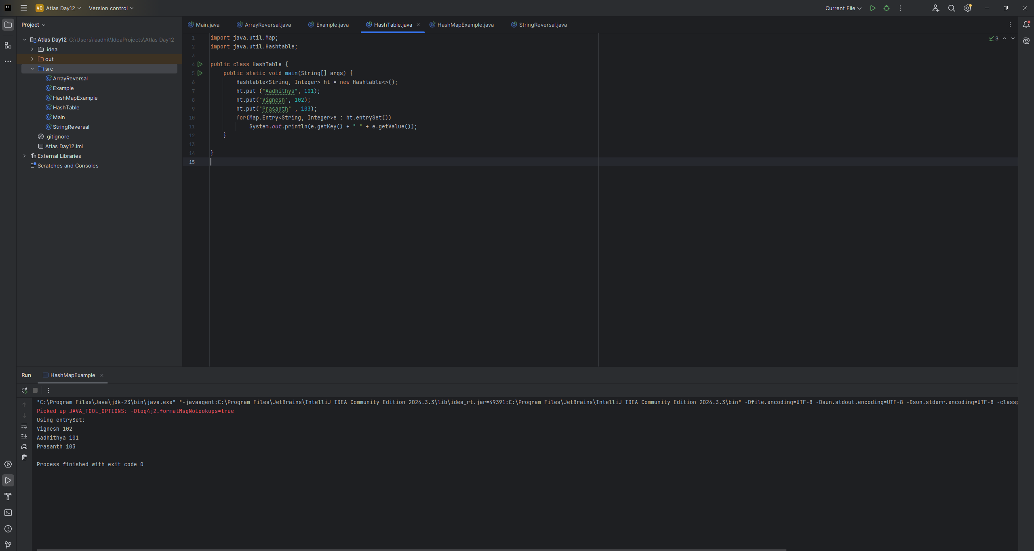
Task 13:
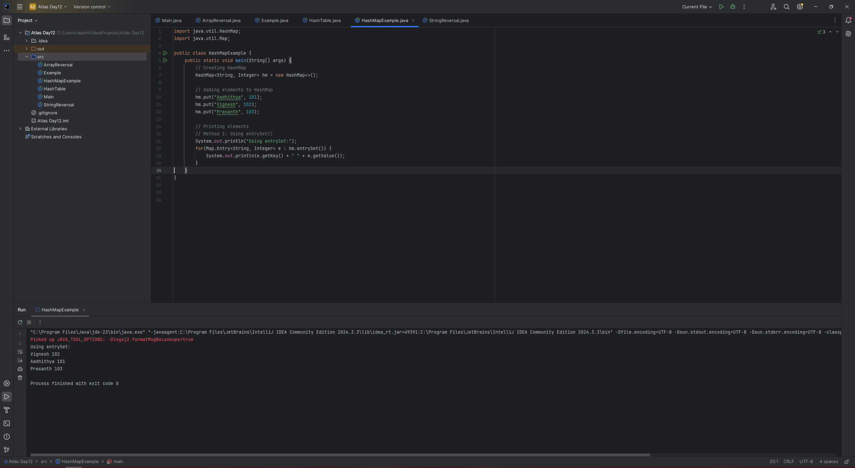

Task 14:
Difference between Hash Table and Hash Map
In Java, both HashMap and HashTable are implementations of the Map interface, used for storing key-value pairs. The primary difference lies in their synchronization: HashMap is not synchronized (and thus not inherently thread-safe), while HashTable is synchronized (and thus thread-safe). This means that HashTable is designed to be safely used by multiple threads concurrently, while HashMap requires external synchronization mechanisms for safe multithreaded access

